**Name:** Saqib Hussain

**Reg No:** 215-saqibhussain151214_Ba_coursemea

Assignment No 2

Q. Make practice to Correct the date format in Excel and give screenshot.

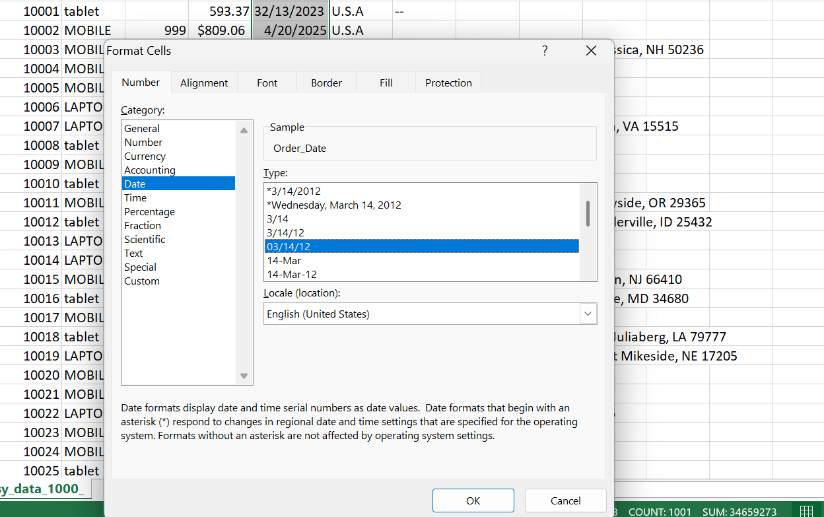

Find unique customers.

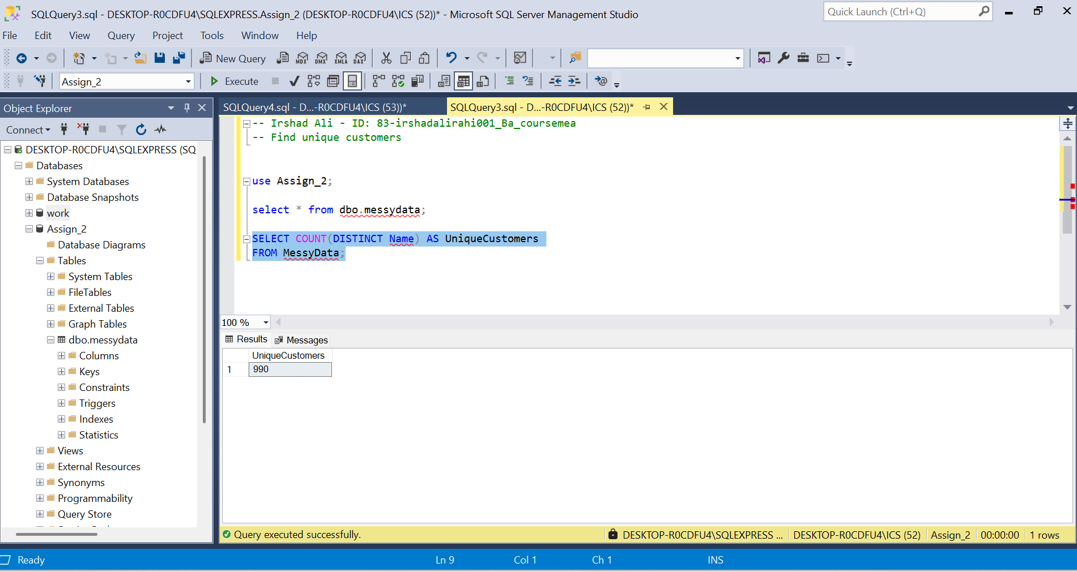

How many mobiles were sold?

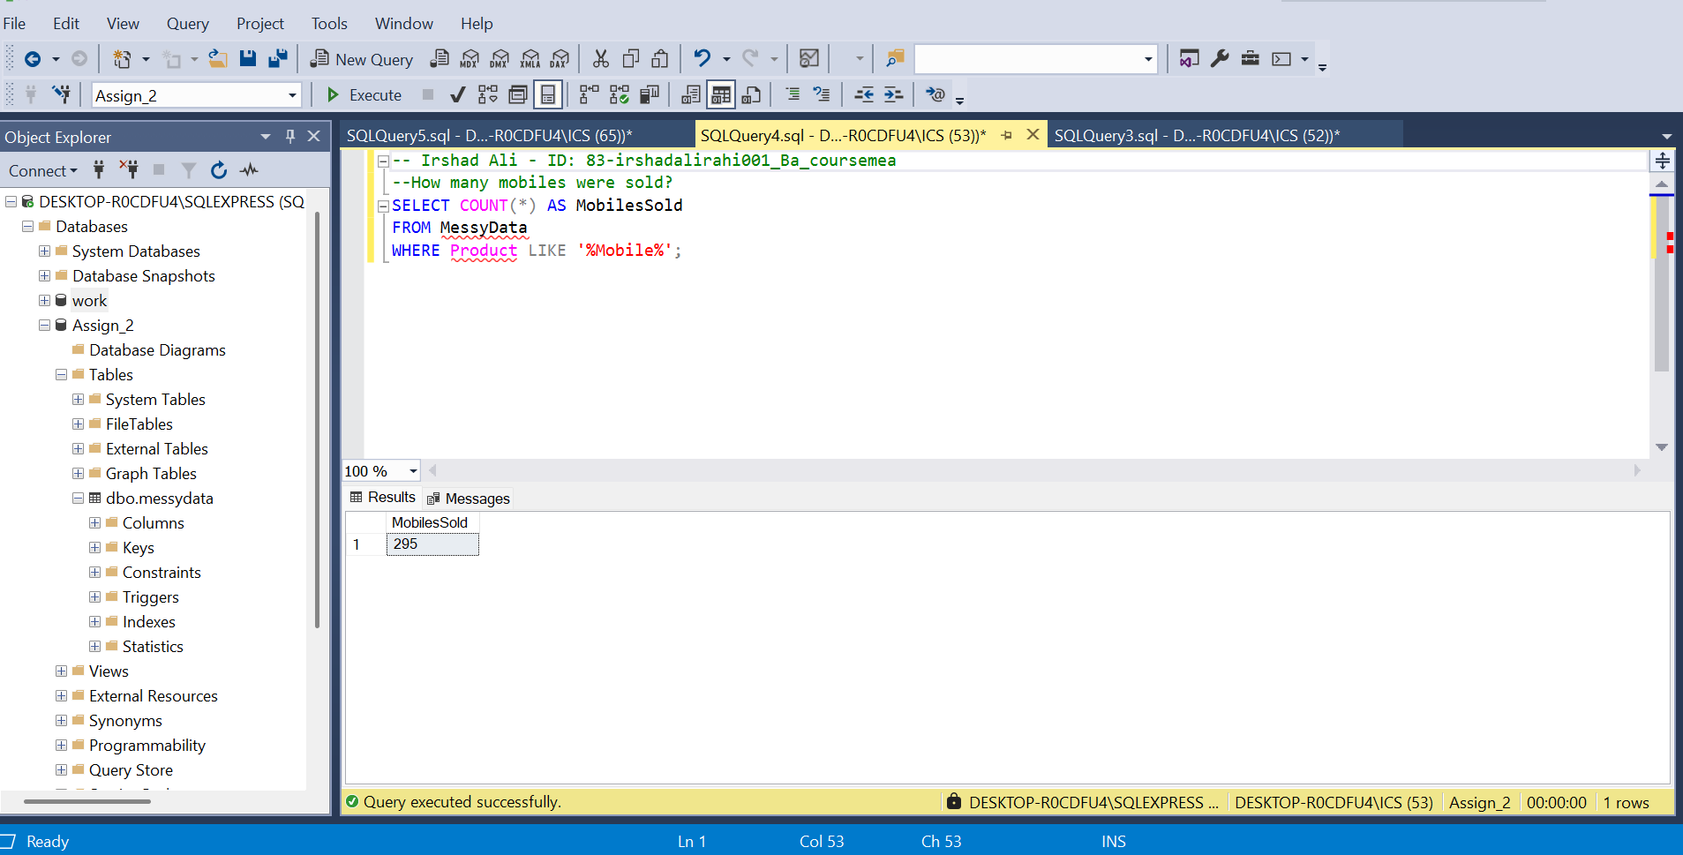

Top Five Products by Sales?

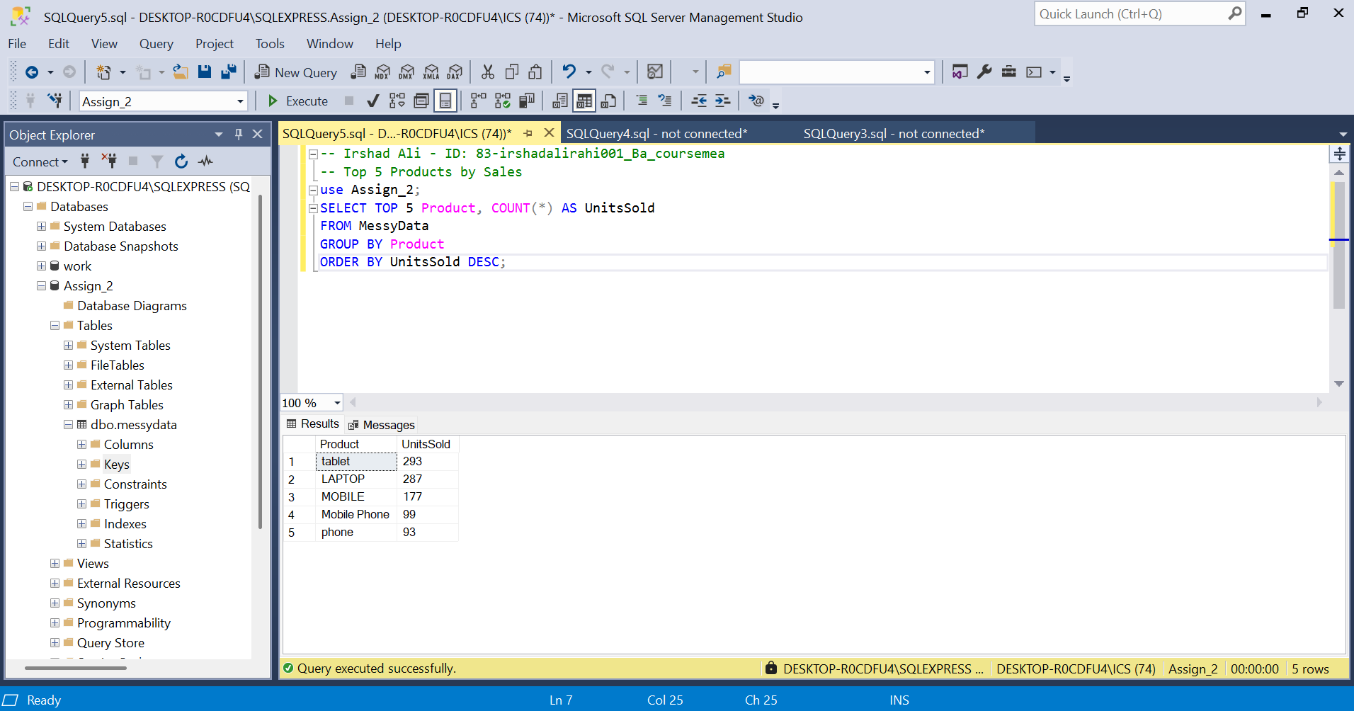

Sales by Country?

